When I found *Dr. Kermit W. Sprocket’s Build Your Own Robot Kit*, I had no idea it would ultimately lead to me saving the world from an alien invasion.

I just liked the idea of building a robot.

I also liked the price. Three bucks.



I was at a yard sale. Or, at least, I thought it was a yard sale.

It turned out it was an *estate sale*, which is slightly different. But I didn’t find that out until later.

I was with my dad that morning, wandering the front lawn of Hammerstrike Manor, a huge mansion that sat on the hill at the edge of town. My friends and I had always wondered about Hammerstrike. It was the kind of place you pointed at from your bike and said things like, “That’s where the mad scientist lives,” or, “You think that place is haunted?

I’d always wondered what the place looked like up close, but I’d never been near it before. So when Dad shook me awake that morning and said, *“Hurry up! They’ve opened Hammerstrike! Everything’s for sale! We’ve got to get there before the best stuff’s gone!”* I thought he was joking.

But here I was, actually standing on the front lawn of the most mysterious house in Brimley Forge, rummaging through tables of dusty treasures while the morning sun glinted off the mansion’s tall, arched windows.

Dad had already disappeared inside. I stayed out front, pretending to be fascinated by a box of cracked teacups, but really, I was stalling. For years my friends and I had joked about this old mansion being haunted. And I knew it wasn’t actually haunted, but my mind was slow to let go of the idea.

So I stayed outside drifting from table to table in the front yard.

Turned out, even the creepiest mansion in Brimley Forge had a lot of the same junk as normal yard sales: baby clothes, mismatched mugs, stacks of old books, and one deeply unsettling ceramic clown lamp.

(sketch of clown lamp)

It also had weird things. Old things. Things that looked like they had been stored in a forgotten attic for a hundred years. There was a collection of rusty old gears in a giant jar. There were boxes and boxes of old maps (lots of the dads in town were fawing over those old maps). There were steel tubes and wooden blocks and iron pincers and things that my grandpa would love but that I had no use for.

And then, sitting between a tangle of extension cords and a pile of yellowed papers, I saw it.

**Dr. Kermit W. Sprocket’s Build Your Own Robot Kit.**

The box was faded and soft at the corners. I slid it out for a better look, lifted the lid…

Inside, the parts were jumbled in a way that made it instantly obvious this kit had been torn through, used, at least a little, and then shoved back together using materials from the kitchen pantry. There were a couple of wheels, some mysterious pieces of clear plastic (parts of the robot’s body, maybe?), a white plastic block that had a grid of tiny pinholes on its face, a bunch of electrical components loose in the box, some more electrical components in a sandwich bag, a coil of wires wrapped in a rubber band, a Lego, a very strange pink plastic robot figurine of some sort, and a booklet titled HOW TO BUILD YOUR FIRST ROBOT, printed in the same cheerful font that was on the box.



I strongly suspected at least a few pieces were missing.

“Find something?” asked the woman running the sale.

“Yeah,” I said, holding up the box.

She smiled. “Tell you what. The price says three, but you can have it for two.”

Sold.

I was still turning the box over in my hands when I heard Dad’s voice calling me from the porch.

“Gavin, come inside, you’ve got to see this place!”

He was standing at the doorway, waving me in, a goofy grin on his face.

It was kind of embarrassing to be honest, but that was my dad. You had to love the guy, even when he was a big ol’ dork.

“Come on!” he called again. “They’ve got the library open. Every book is for sale.”

I took a deep breath and started up the steps. How bad could it be in there? Half the town was here this morning, looking around. If there were ghosts in there wanting to menace people, they had a lot to choose from.

Dad went back inside as soon as he saw me approach, so I had to enter alone. The air grew cooler as soon as I crossed the threshold.

The minute I stepped inside, the sheer size of the place overwhelmed me.

The front hall opened into a vast, echoing space that could have fit my entire house inside it, twice. A grand staircase curled upward along the far wall, splitting halfway to form a balcony lined with carved railings and dusty portraits. Shafts of sunlight pushed through tall windows draped in fabric so old it looked ready to crumble.

A chandelier hung overhead, its crystals coated in years of dust. The light that slipped through them scattered in strange, fractured shapes across the marble floor, like the house was playing tricks with the sun.

I tightened my grip on the robot kit and tried to act casual.

There was a crowd of people between me and Dad, but he spotted me right away.

“The library’s this way!” he called, pointing down a long hall.

He meant for me to follow him, and I did, at first.

I started down the hall after Dad, weaving between people and trying not to bump anyone with the box in my hands.

That’s when I saw her.

At the far end of the hall stood Aanya Carter, flanked by her parents and her little brother, the four of them looking at a painting so enormous it could’ve doubled as a movie screen. Mr. Carter was saying something in his serious grown-up voice, and Aanya laughed.

I froze.

Not because she’d seen me (thankfully, she hadn’t) but because my brain suddenly forgot how to walk like a normal human. My legs were like, *Do we still do that? Walking? Is that still our thing?*

I turned sideways, pretending to be deeply fascinated by a display of dusty candlesticks. I risked one quick glance back. She was still there. Still laughing. Still Aanya.

*Go say hi*, I told myself.

It had been months since I’d seen her.

*Just go say hi.*

And then she turned, in what felt like slow motion, and the light glistened off her hair in an impossible movie-trailer kind of way and the air around her might as well have been sparkling at this point and my brain, helpful as ever, cued up a full symphony of imaginary background music and I decided it was definitely time to retreat.[1]

My feelings about Aanya Carter were complicated.

I spun on my heel and headed the other way, down a narrower hall that bent at a weird angle and disappeared into shadow. It looked like the kind of hallway no one was supposed to go down. So naturally, I went.

The corridor twisted around a corner and opened into a small bedroom packed tight with furniture. Antique chairs, antique lamps, an antique clock sitting on an antique table, all of it resting on a creaky hardwood floor. I ducked behind a wardrobe, partly because it looked cool, partly because I still wasn’t ready to risk walking past Aanya again.

Voices echoed down the hall. Grown-ups.

“…we think it goes to the basement,” said a man. “But no one’s been able to open it.”

“That’s wild,” said a woman. “You mean no one has a key?”

“Not the family. Not the realtor. Not even the Marindale Foundation people. They said it’s been sealed since before they took ownership.”

The voices were getting closer.

Was I supposed to be in this room? Probably not. Worried that I might get in trouble if they found me, I pressed myself all the way behind the wardrobe, back against the wall, clutching the robot kit tight to my chest.

“Which door are we talking about?” the woman asked.

“This blue one right here,” said the man.

They were in the room with me now. Through a sliver of light between the wardrobe and the wall I could see them, and the door they were talking about.

It was enormous. Heavy wood, banded with metal bolts, covered in chipped blue paint.

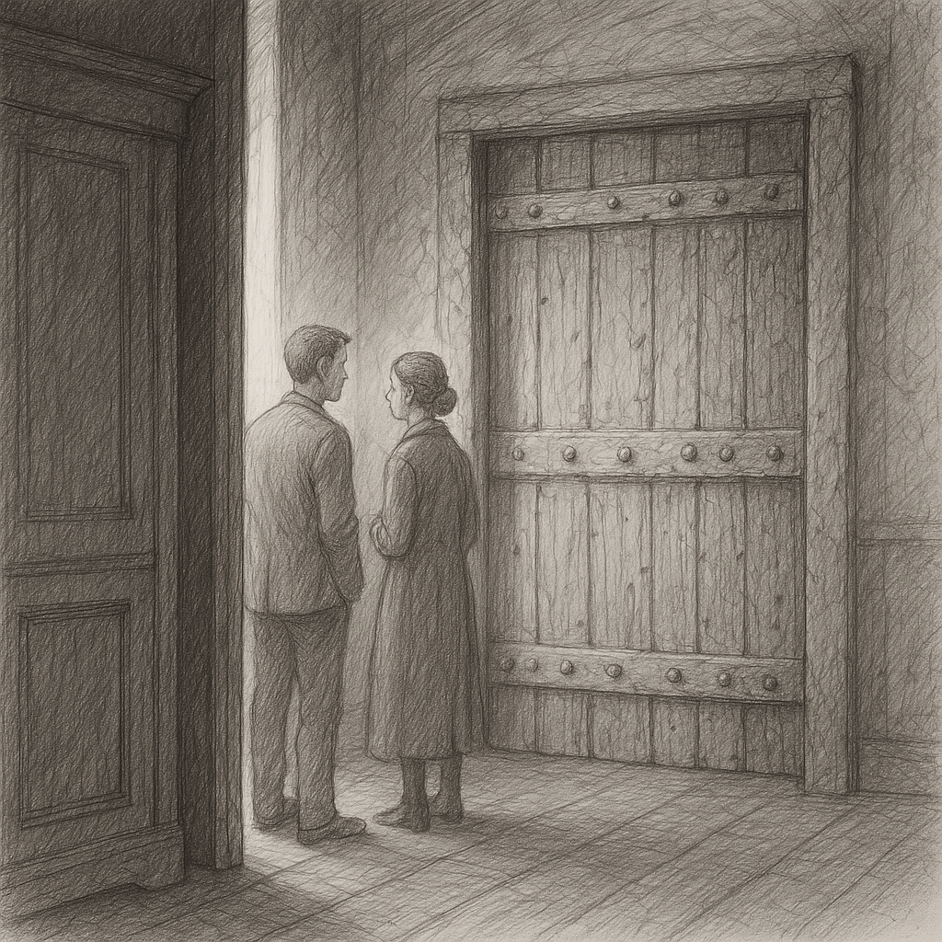

“I don’t even see how you unlock it,” said the woman. “There’s no keyhole.”

“We think it’s electronic,” said the man. “You need some kind of keycard, or something you hold up to this sensor here.”

He pointed at a black square panel mounted on the wall beside the door. The panel was smooth and glossy, with a glowing red spiral on its face.

“There was no mention of this door or this lock in the estate documents?” the woman said.

“Nothing at all,” said the man. “The Marindale Foundation has decided to leave it sealed, at least for now.”

“And they own the house now, right?”

“They do, but the Tanthrop Hammond company is already trying to buy it.”

“What do they want with this old place?”

“No clue, but apparently they’ve already made an offer, even though the house isn’t for sale.”

I stayed perfectly still through all this. I could no longer see the adults who were talking. It felt like the voices were drifting farther away.

“That’s not the only mystery in this old house,” the man said, his voice fading down the hall. “If you’ll come with me…”

And then they were gone.

I waited a few seconds, listening. Nothing but the faint ticking of the clock.

The room felt bigger now, emptier.

I eased out from behind the wardrobe. The black panel beside the door caught my eye. If you looked closely, you could see that the red spiral was glowing, faintly.

Right then, Aanya and her family passed by outside, their voices echoing softly as they headed for the exit.

The coast was clear now. I could go down the hall and find Dad.

But first I wanted to try something.

I set the robot kit down, stepped closer to the blue door, and wrapped both hands around the handle.

I gave it a soft tug at first. Then a hard pull.

It didn’t budge.

And now the voices quickly faded as both adults left the room, leaving me in there alone.

I waited a few seconds to be sure it was safe, then I stepped out from behind the wardrobe, intending to leave the bedroom. Right as I did, Aanya and her family appeared outside the door, backs facing me. They had emerged from the hall and were now headed for the exit.

I ducked back into the room, and found myself standing right next to the blue door and mysterious black panel the adults had been talking about.

Unable to help myself, I grabbed on the handle and pulled.

Locked tight, just like they said.

Wouldn’t it have been funny if I was able to open it?

I looked back down the hall. It was empty, Coast was clear.

Time to go find Grandpa.

But I did like looking at the black square with the red spiral.

I loved the idea that

something about it made the hair on my arms prickle. It didn’t look new, exactly, but it didn’t look old either. It looked… awake.

The door was massive, banded with metal bolts and covered in layers of chipped green paint. A black square panel was mounted on the wall beside it—smooth and glossy, with a single **curving red arc** glowing faintly in the center.

(he loses track of Grandpa because of Aanya

“Dad?” I said softly.

But my voice sounded small in the echoing hall.

A minute later I found Grandpa looking through some old books on the front porch. I showed him the robot kit.

“Imagine that! You found a robot kit that belonged to Marvin Marindale!” he said with glee.

“Who’s Marvin Marindale?” I asked.

“He’s the guy who owned this house and all this stuff,” Grandpa said.

“Where is he now?”

“Well, he’s dead, of course. That’s why all his stuff’s for sale.”

“Oh,” I said.

I felt a twinge of sadness for the man whose robot kit was now mine.

“So he’s the man who owned this house?” I said.

“This house and half our town,” said Grandpa. “Very successful man, Marvin Marindale. Successful and eccentric.”

“Eccentric?” I said.

Grandpa smiled. “Come with me,” he said. “I want to show you something.”

Grandpa led me through the front door and into the house.

(now we need a good description of Hammerstrike, and Gavin needs to see the glyph on one of the doors – he’ll know later that that’s how it opens)

(have Grandpa show off

“I liked the title too,” said Grandpa. “Very evocative. Very much like Marvin Marindale.”

“You knew him?” I asked. “The guy who owned this house?”

“Oh yes,” said Grandpa. “There was a time when I knew Marvin quite well. Smartest man I ever met.

An hour later I was on my bike, pedaling straight to Grandpa’s workshop, also known as The Fortress.

Grandpa’s workshop was a squat concrete building that, years ago, before I was born, used to be some kind of store or something. Apparently the store got robbed, then the owners spent big bucks to put metal bars over the window and an iron gate around the whole place (which was why it always looked like a fortress to me), and then the store went out of business anyway. That’s when Grandpa bought the building and filled it with all his old tools, machines, workbenches, half-finished inventions, and about a million strange objects whose purpose only he knew.

(sketch of the Fortress)

I rang the buzzer (which sounded like a doorbell mixed with an air-raid siren). A minute later, Grandpa appeared. He was wearing his usual uniform of a button-down work shirt and blue jeans. He was wiping his hands with a towel. He had a smudge of machine grease on his cheek.

“What’ve you got there?” he said, eyeing the box under my arm.

“I found this at a garage sale,” I said, grinning. “Dr. Kermit W. Sprocket’s Robot Kit. Two bucks.”

“Two bucks, huh?” he said. “Well, come on in. Let’s have a look at this two-buck robot kit.”

The Fortress usually smelled of solder and saw dust, and I remember that, on this day, there was also a hint of mineral oil, which was the smell of Grandpa doing maintenance work on one of his big machines.

Grandpa had machines to that cut, drilled, sawed, and smoothed. He made things out of metal usually, but sometimes also out of wood or plastic. When I was little, and the Fortress was where Grandpa ran a business, he made little electronic contraptions for all the miners in town, but now he was retired and mostly made weird gizmos that only he understood.

*I mostly just putter about*, is what he would say if you asked him what he did all day in the Fortress.

“What are you working on today, Grandpa?” I asked.

“Oh nothing in particular,” he said. “Certainly nothing as exciting as a robot kit.”

We went to his workbench. I set the box down and opened it. Grandpa leaned in and started picking through the pieces. He set aside the Lego and the pink figurine. “Yard sale detritus,” he muttered, which made me laugh.

To tell you the truth, I was already starting to like the pink figurine. He was a weird little guy. At first I thought he was a robot but he was actually a little different than that. He was like a person made out of bike lock parts? Wonderfully strange.

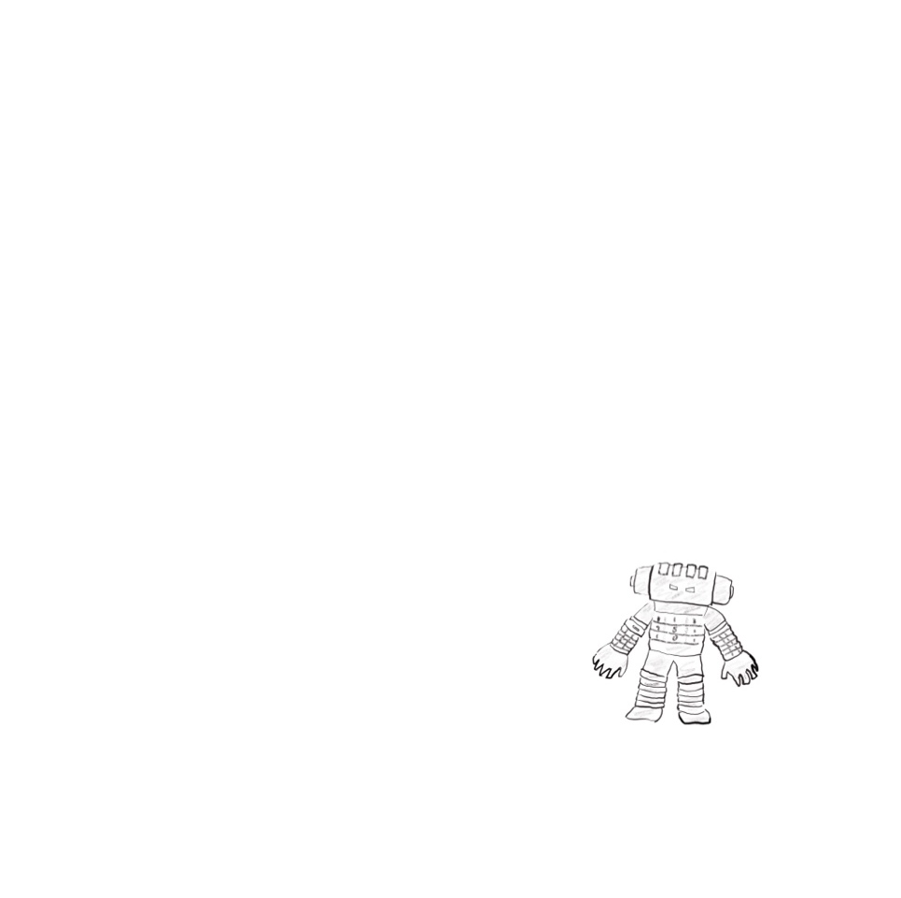

Grandpa was still going through the rest of the kit. “Hmm. No motor controller. No microcontroller. Without those, your robot isn’t going to walk or roll or do much of anything.”

I felt my excitement deflating.

Then he held up the white plastic block. “Ahhh…but this is a useful tool.”



“What is it?” I said.

“It’s called a breadboard.”

“A breadboard?”

“It’s for making circuits,” Grandpa said. “Back in the day, if an engineer wanted to prototype a circuit, he would screw components into a wooden bread-cutting board. Today we use these little plastic bricks instead, but we still call them breadboards.”

He kept going through the pile.

“You have a nice little assortment of resistors here,” he said.

He held up a piece that looked like this.



“And jumper wires.”



“And LED’s.”



“Looks like you also have a connector for a 9-volt battery, which will be helpful, and of course you’ve got the instruction booklet. You can read that if you’d like. I won’t need it.”

He tossed the instruction booklet aside.

“What can we build with all that?” I asked.

Grandpa ignored the question. “Tell you what, let’s make a deal.”

Classic Grandpa. His “deals” usually meant trading something I wanted—his wisdom, his tools, or occasionally cash—for something he wanted me to do, like chores, homework, or, one time, feeding his neighbor’s pet snake for a week.

“Before you can make a robot, you have to understand circuits.” He tapped the white plastic block, the one he’d called a *breadboard*. “This is the perfect place to start.”

“So what deal are we making?” I asked.

“You let me teach you about circuits, motors, and electronics, you do the hard work required to learn something new, and I’ll buy the parts you’re missing from this robot kit.”

This sounded like a pretty good deal to me.

“So I’m actually gonna be able to build a robot?” I said.

“In time,” said Grandpa. “But only if you promise to be patient. You have a lot to learn before you’re ready to just start making robots.”

“But I will be able to make one?”

“If you work hard enough, I don’t see why not.”

I was so excited, and at that moment, I was feeling like I’d lucked into the best $2 yard sale find ever.

I didn’t know it yet, but Dr. Kermit W. Sprocket had just dragged me into the adventure of my life.

1. If you’re curious, the music in my head at that moment sounded a lot like the Rachmaninoff’s Rhapsody on a Theme of Paginini, Variation 18